**Playbook: User Creation and Deactivation Workflow**

Playbook Objective: This playbook automates the process of creating a new user in the Beyond Identity system and immediately disabling that user based on certain conditions. The workflow is useful for testing, user provisioning/deprovisioning scenarios, or security incident handling.

Playbook Steps:

1. **Trigger:** New User Creation

This action triggers the creation of a new user in the Beyond Identity platform via the Beyond Identity SCIM API.

**Inputs:**

userName: The username for the new user.

displayName: The display name of the user.

email: The email address of the user.

givenName: The user's first name.

familyName: The user's last name.

**Action Logic**: This action sends a POST request to the Beyond Identity SCIM API with the above inputs. Upon success, it retrieves and stores the newly created user’s ID and status.

**Outputs**:

userId: The unique ID of the newly created user.

status: Success or error message.

#### **Condition: Check If User Created Successfully**

This condition checks the output from the "Create New User" action to ensure the user was created successfully.

**Condition**:

* + If status == 'success', proceed to the next step.
  + If status != 'success', stop the playbook and log the error.

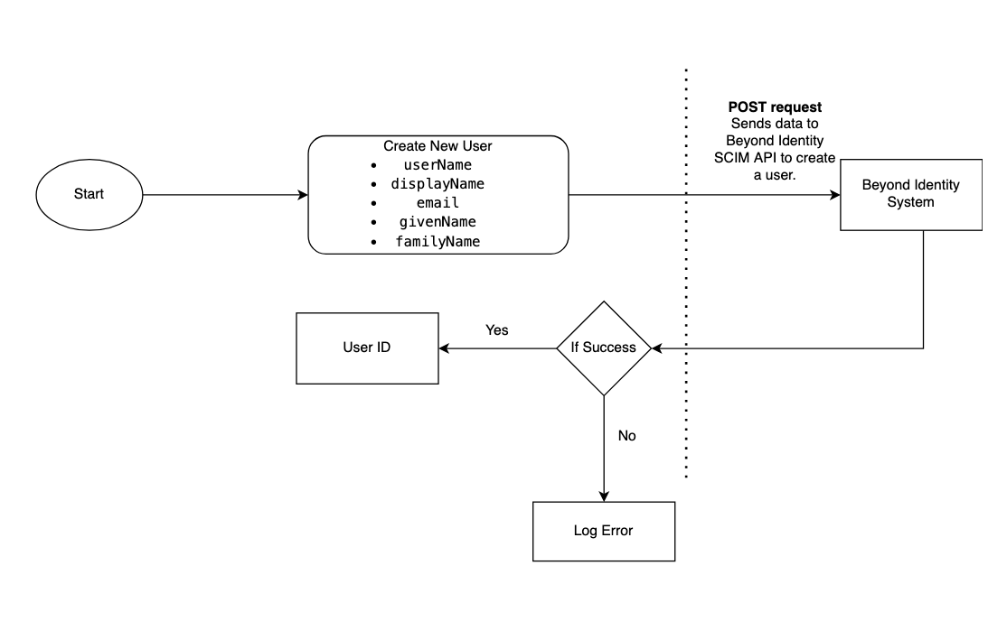

1. **Trigger:** Disable User

This action disables the user that was created in the previous step. It uses the userId from the "Create New User" action to identify the user to be disabled in the Beyond Identity system.

Input: userId- The unique ID of the user to be disabled (retrieved from the "Create New User" action).

**Action Logic**: This action sends a PATCH request to the Beyond Identity SCIM API to update the user's status to inactive (disabled).

#### **Condition: Check If User Was Disabled Successfully**

This condition checks if the user was successfully disabled.

**Condition**:

* + If status == 'success', log the success message.
  + If status != 'success', log the error and stop the playbook.

